# Ping Connectivity

For OFFICE PC-1 and OFFICE PC-2

Step 1: Go the virtual machine settings, select Network

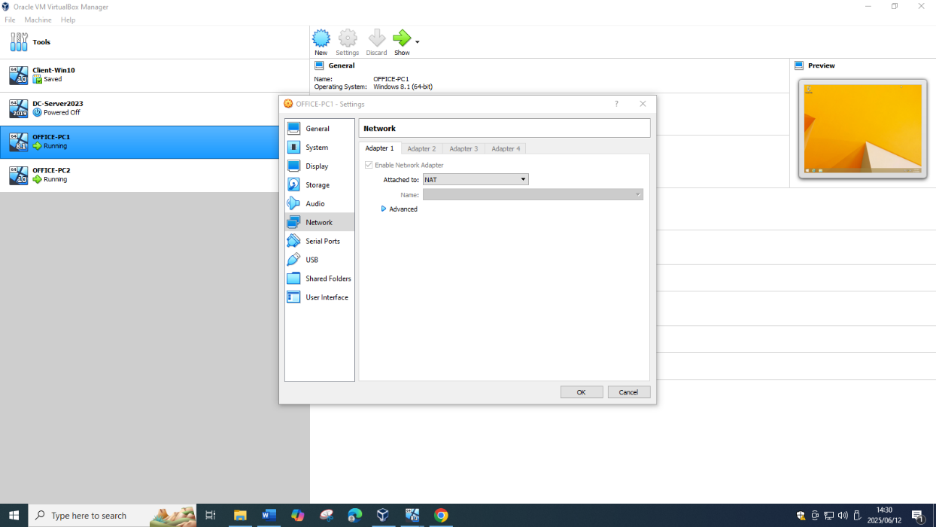

Step 2: Attached to Internal Network, name EduvosNet

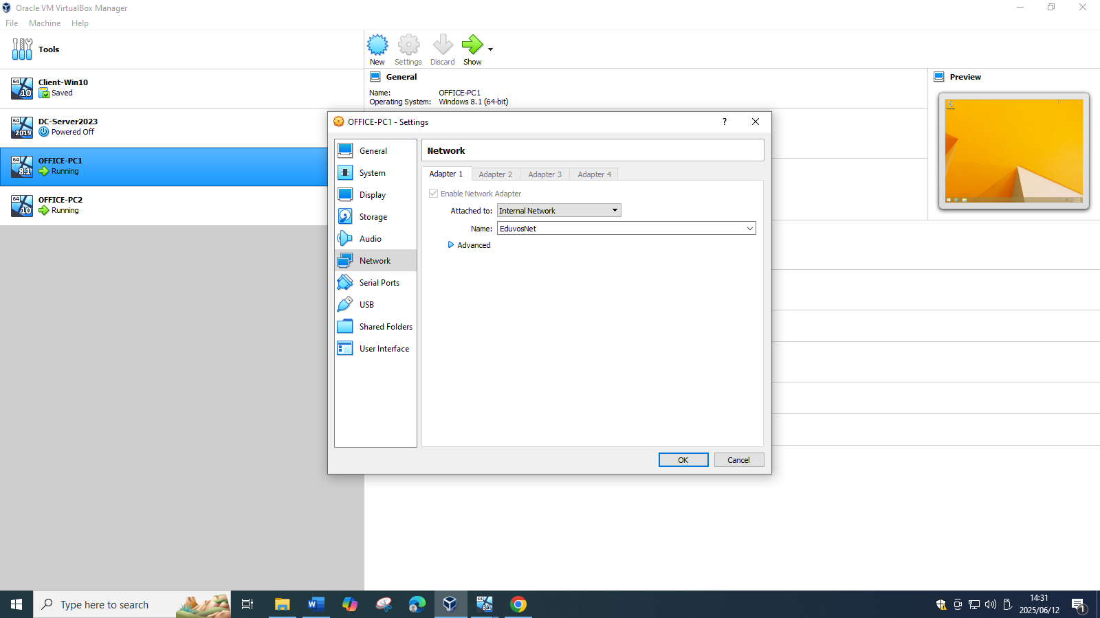

Step 3: On OFFICE-PC1 go to Control Panel then Network and Sharing Center, click Change advanced sharing settings

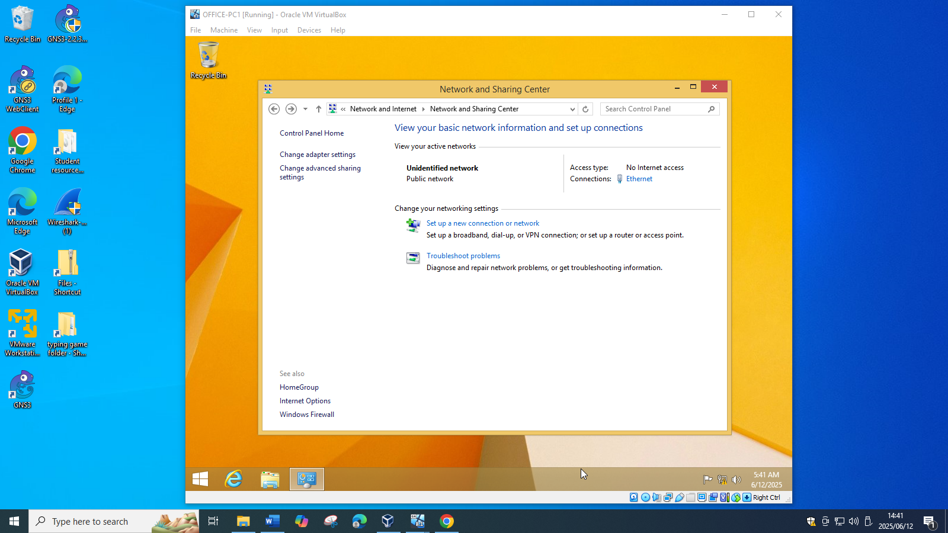

Step 4: Turn on Network Discovery and Turn on File and printer sharing

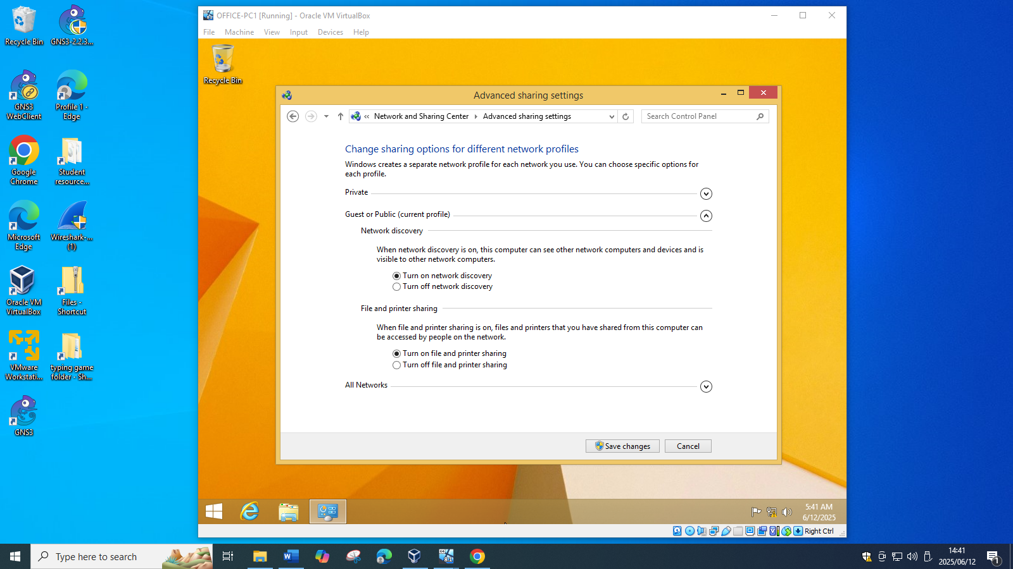

Step 5: On OFFICE-PC2 go to Control Panel then Network and Sharing Center, click Change advanced sharing settings

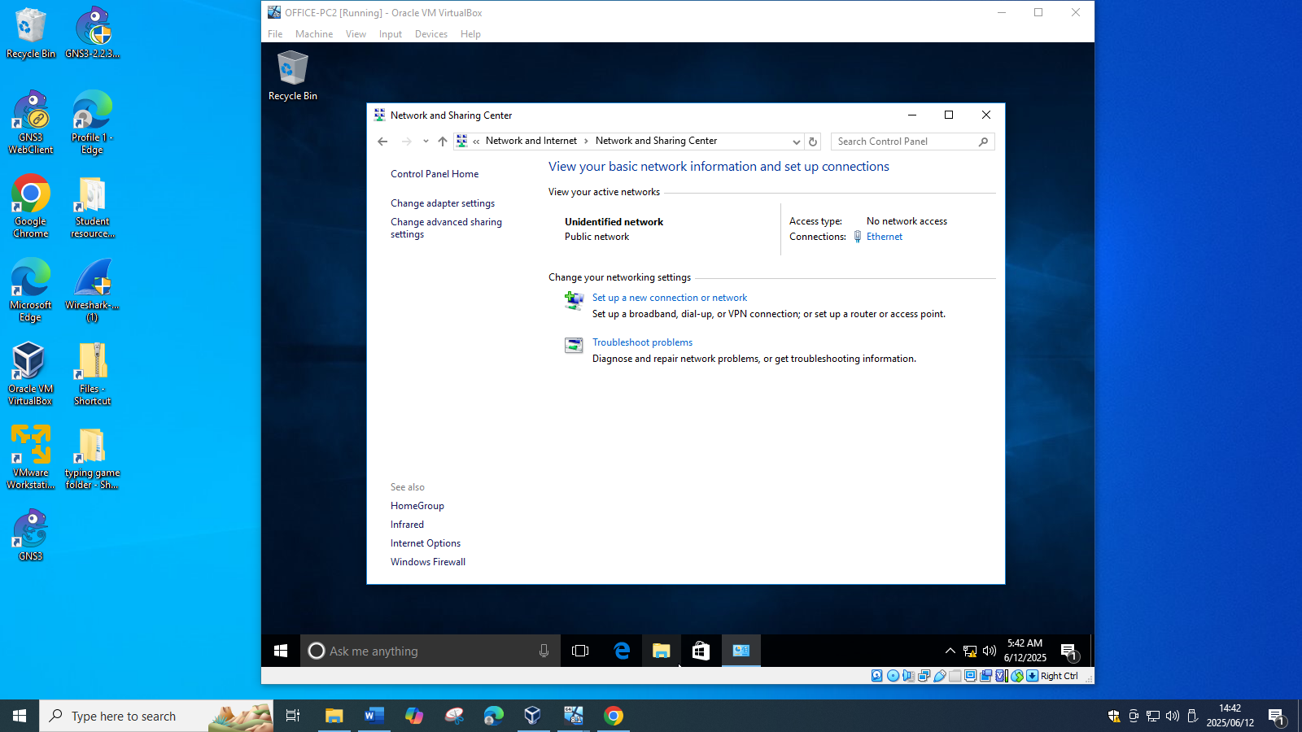

Step 6: Turn on network discovery and turn on file and printer sharing

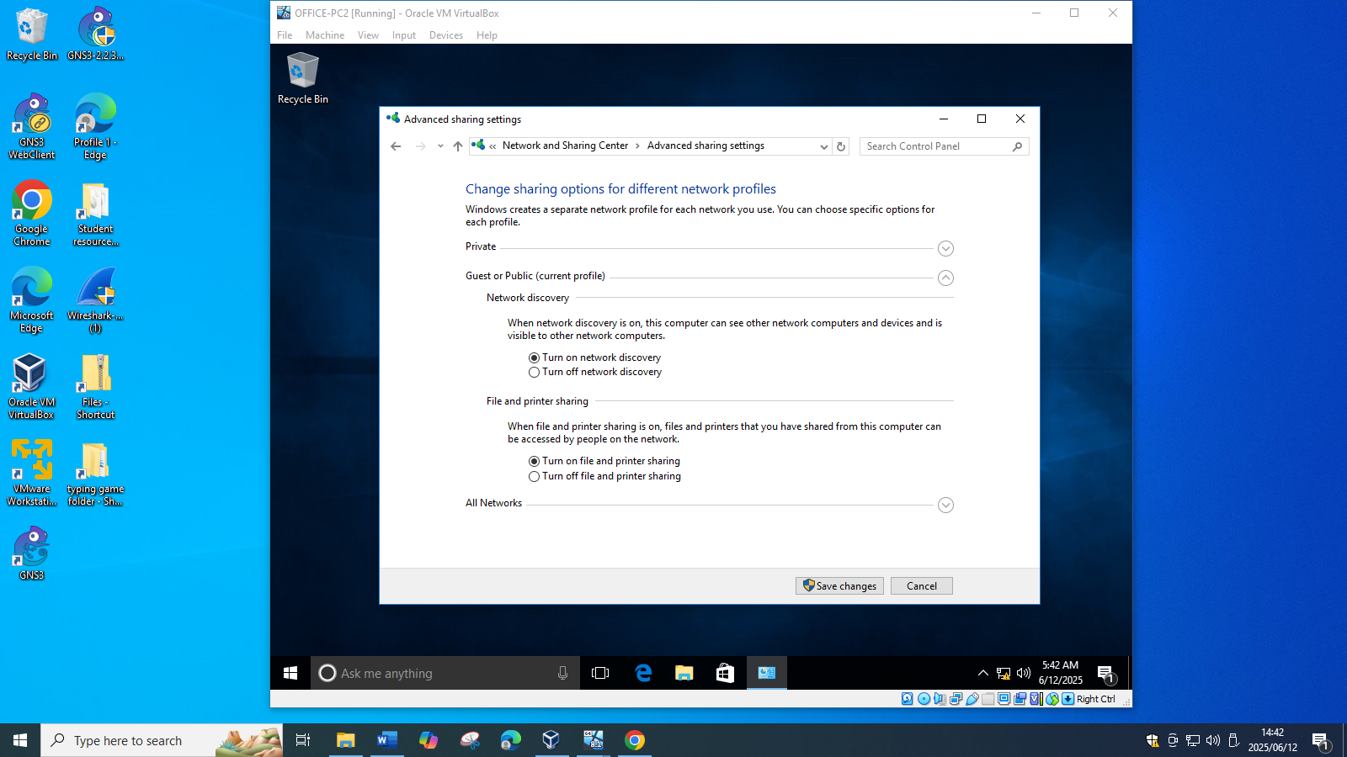

Step 7: Open Command Prompt

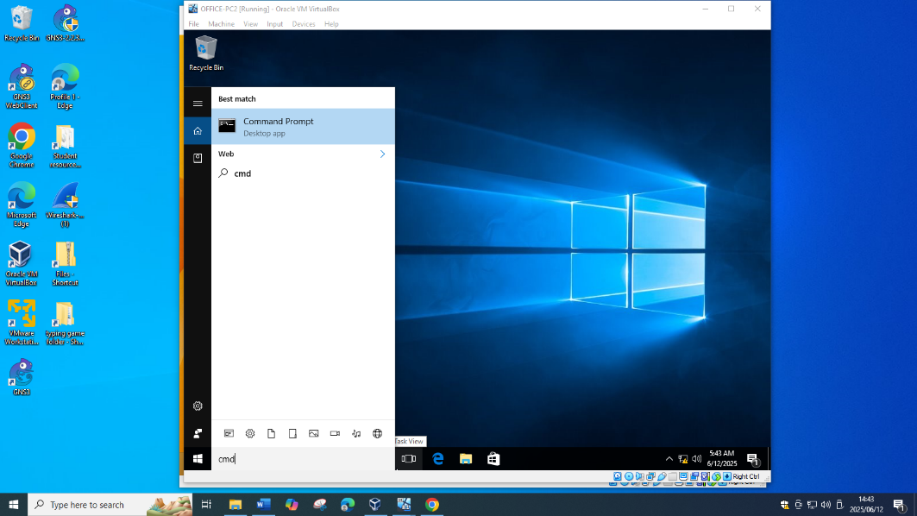

Step 9: ping 192.168.1.65

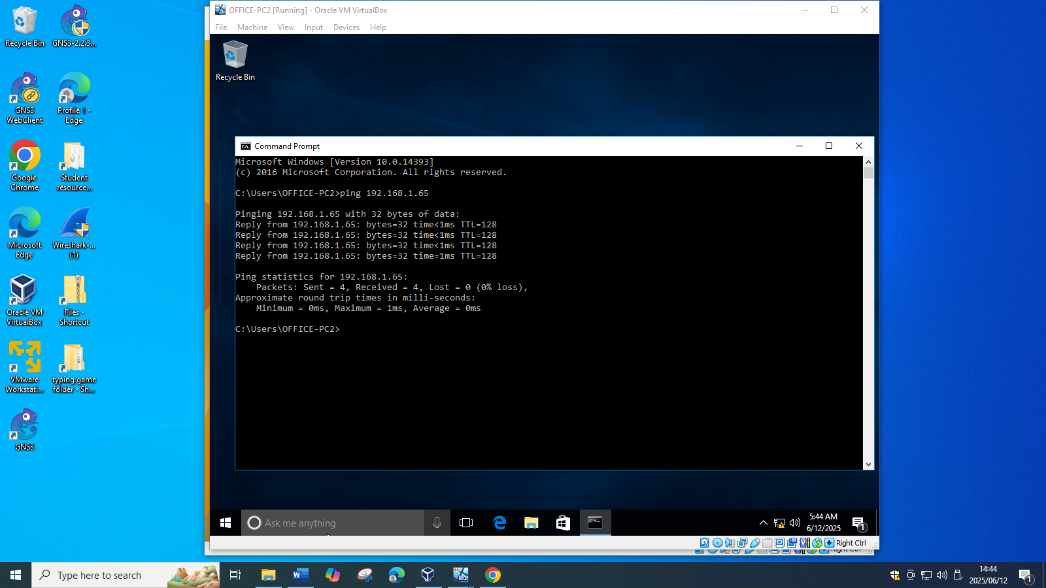

On OFFICE-PC1

Step 1: Open Command Prompt

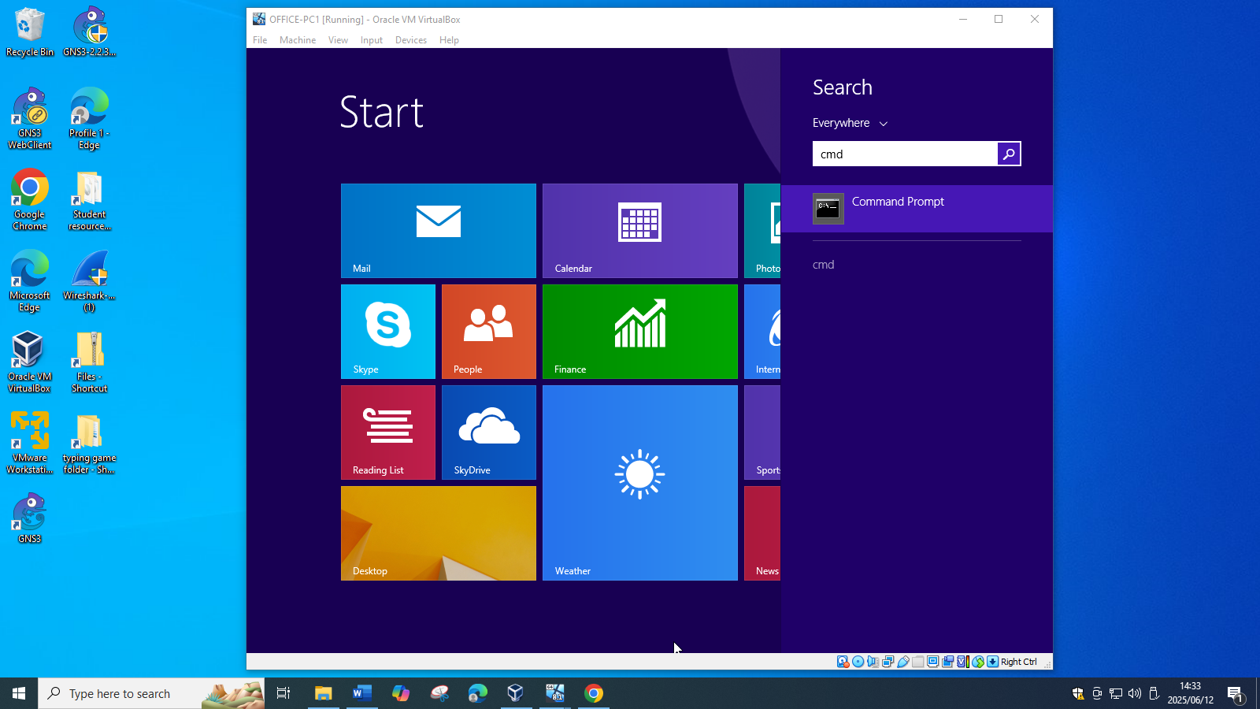

Step 2: ping 192.168.1.78

